**GEOGRAPHICAL FEATURES/LANDSCAPE**

***Препоръчваме да се използва след Unit 8 (Energy for Bulgaria 5th grade)***

**Get started**

**Exercise 1 What’s your favourite place for a holiday?**

**Vocabulary: Landscape**

**Exercise 2 <track 9-01> Listen and repeat. Then find the words for the pictures (A–E). Which words are not in the pictures?**

• coast • forest • island • lake • mountain • ocean • river • sea • tree

*А - forest*

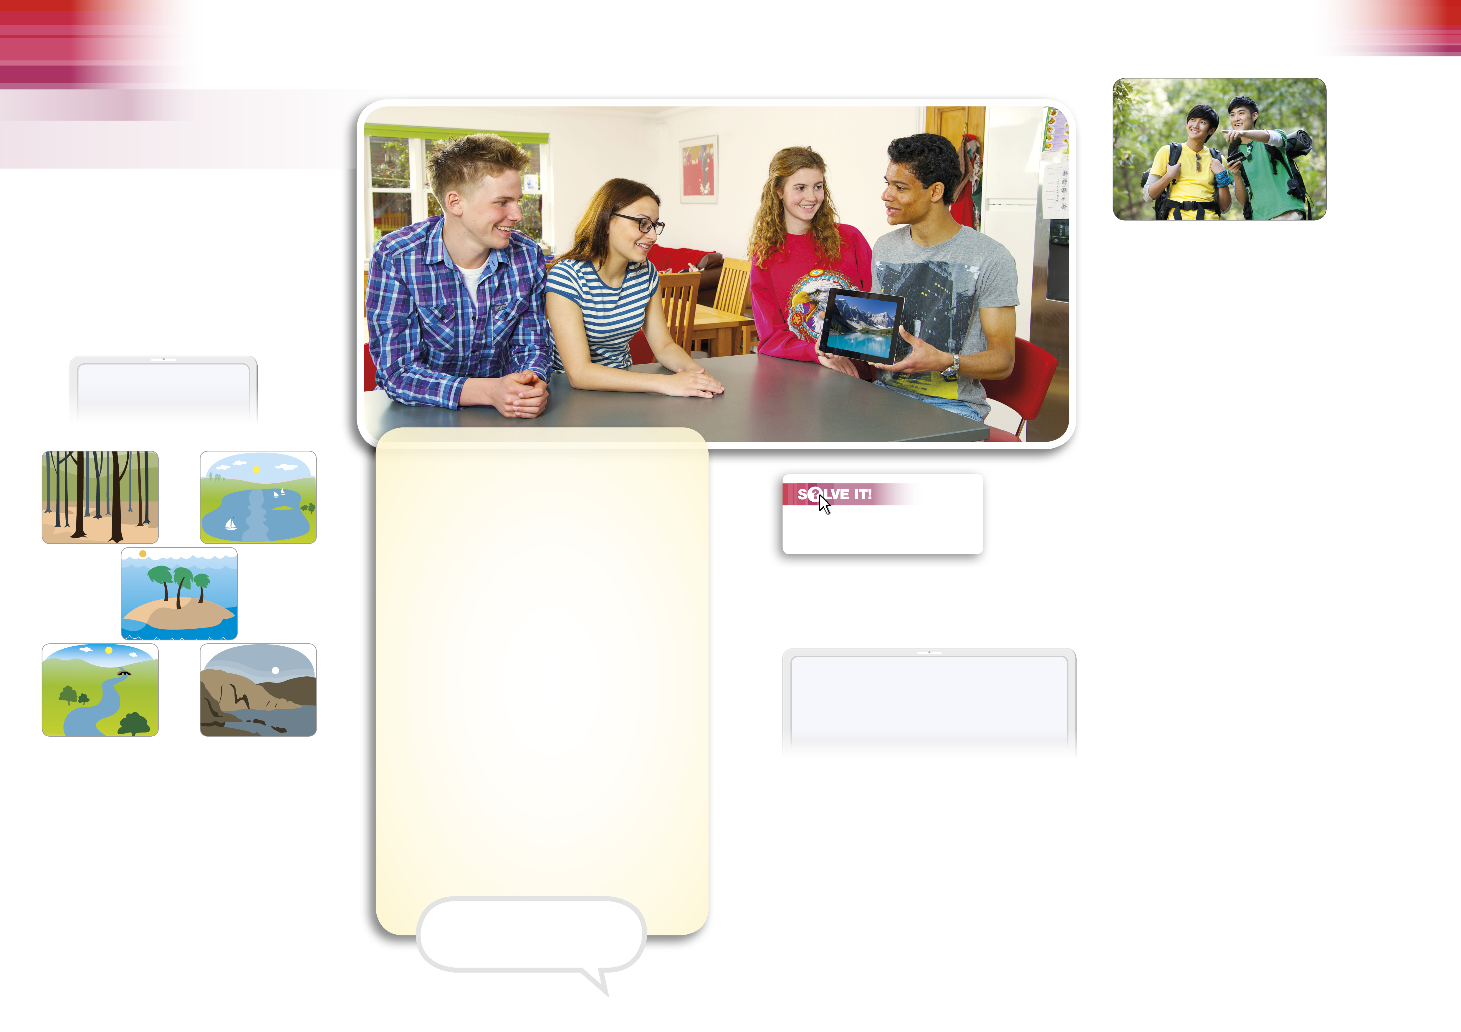

**A B**

**C**

**D E**

**Dialogue**

**Exercise 3 <track 9-02> Listen and read. Find the phrases in the dialogue. Check what they mean.**

Tom: Where **did** you **take** these photos? They’re fantastic.

Daniel: In Canada. I **went** there two years **ago**.

Emma: **Did** you **have** a good time?

Daniel: Yes, it was great fun.

Tom: What **did** you **do**?

Daniel: We **flew** to Vancouver Island and **stayed** there for a week. We **saw** whales and

**went** swimming with them. They were so awesome!

Katy: Is there a beach on Vancouver Island?

Tom: Of course there is. It’s an island. It’s in the sea.

Daniel: Actually, it’s not the sea, it’s the ocean. The Pacific Ocean. Then we **went** to

the Rocky Mountains for a week.

Tom: **Did** you **climb** them?

Daniel: No, I **didn’t**. Look, they’re about 4,000 metres high. But I **went** mountain biking.

Emma: I like mountain climbing. Six months **ago** I **did** the Three Peaks Challenge.

Tom: What’s that?

Emma: I climbed three mountains in Scotland, England and Wales. I **did** it in twenty-four

hours.

Daniel: That's incredible!

Katy: I can climb, too.

Tom: You?

Katy: Yes, I climbed the stairs five minutes **ago**!

**Comprehension**

**Exercise 4 Answer the questions.**

1 Where did Daniel take the photos?

2 How many places did Daniel go to on holiday?

3 How long was Daniel's holiday?

4 How high are the Rocky Mountains?

5 Where did Emma climb three mountains?

**Vocabulary: Holiday activities**

**Exercise 5 <track 9-03> Listen and repeat. Then write the activities in the three groups.**

**Phrases with go**

• go climbing • go mountain biking • go shopping • go sightseeing • go skiing • go sunbathing • go swimming • go to a museum • go to the beach • go windsurfing

**In a town In the mountains By the sea**

*go sightseeing _______________ _______________*

*_______________ _______________ _______________*

*_______________ _______________ _______________*

*_______________ _______________ _______________*

*_______________ _______________ _______________*

**Exercise 6 Read the dialogue again. Notice the words in bold.**

**Irregular verbs**

have – had do – did go – went take – took see – saw

**Practice**

**Exercise 7 Complete the sentences using the past simple of the verbs in brackets.**

1 I (1) ***didn’t*** have (not have) a bad holiday.

I (2) ***had*** (have) a great holiday.

2 I (3)……………………. (not go) to Spain. I (4)…………………………….. (go) to Switzerland.

3 I (5)……………………… (not go) alone. My sister (6) ………………………………….. (come) with me.

4 We (7)…………………. (not fly). We (8)……………………………. (drive).

5 We (9)……………………………. (not sleep) outside. We (10)………………….. (sleep) in a hotel.

6 I (11)………………………….. (not buy) clothes. I (12) …………………………….(buy) a watch.

7 We (13)………………………… (not see) Everest. We (14)………………………….. (see) Mont Blanc.

8 We (15)……………………………… (not get) home last week. We (16)…………………………….. (get)home yesterday.

**Past simple with ago**

When did you go to Canada?

I went to Canada two years ago.

Six months ago I climbed three mountains.

**Exercise 8 Ask and answer about Sam and Jim’s trip using the past simple and ago.**

Sam and Jim are travelling around America.

Today is Thursday 12th June. It is 3 p.m.

*A: When did Sam and Jim buy plane tickets to America?*

*B: They bought the tickets four months ago.*



**Listen**

**Exercise 9 <track 9-04> Listen to Martin and answer the questions.**

1 When did Martin first go to Indonesia?

2 How did he get to Jakarta?

3 How many islands did he visit?

4 What food did he eat?

5 What did he see in Kenya?

**Speak**

**Exercise 10 Talk about your last holiday. Ask and answer. Invent answers if you like.**

1 How was your holiday?

2 Where/When did you go?

3 Where did you stay?

4 Who did you go with?

5 What did you do?

6 What was the food like?

**Extra practice**

**Exercise 1** **Write sentences in the past simple.**

1 Katy/not do/her Spanish homework. She/do/her French homework. Katy didn’t do her Spanish homework. She did her French homework.

_____________________________________________________________________________

2 Tom/not make/biscuits. He/make/a birthday cake.

_____________________________________________________________________________

3 My brother/not go/to America. He/go/to Australia.

_____________________________________________________________________________

4 We/not buy/Iron Man 2 DVD. We/buy/Iron Man 3 DVD.

_____________________________________________________________________________

5 Daniel/not have/a PS3. He/have/an Xbox.

_____________________________________________________________________________

6 I/not buy/a book. I/buy/a CD.

_____________________________________________________________________________

**Exercise 2** **Use the information in the table to write sentences in your notebook using ago**.

*1 Clare went to school 30 minutes ago.*

**When?** **Now**

1 Clare/school/8.30 9.00

2 My parents/fly/Chile/Thursday Saturday

3 Sue/leave/school/2012 2015

4 We/swim/with whales/August December

5 Steve/drive/to Spain/2010 2015

6 They/eat/dinner/7 o’clock 11 o’clock